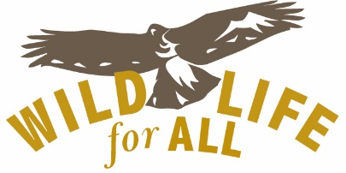
The mission of Wildlife for All is to lead a national campaign to reform state wildlife management in the U.S. to be more to be more democratic, just, compassionate, and focused on protecting wild species and ecosystems.
The contentious wildlife issues we see in state after state—wildlife killing contests, carnivore hunting and trapping, trophy hunting, baiting, etc.—are symptoms of the entrenched system of wildlife management in place in the U.S. today. The system itself -- built on an ethos of domination and exploitation, intended mainly to serve consumptive users, dismissive of other values and voices, not based on sound science--is a barrier to achieving authentic coexistence with wild creatures and meaningful biodiversity protection, and must be changed.
Wildlife for All is the only organization in the U.S. addressing these systemic problems in a coordinated and strategic way on a national scale, while articulating and promoting an alternative management paradigm based on science, respect and democratic norms of governance.
Since launching the campaign in 2021 (as the sole focus of a previously existing nonprofit), we have: built a national coalition of governance reform advocates in more than 30 states (and growing); created a new website containing a wealth of useful information not found anywhere else for reform advocates; put together an advisory committee that includes some of the most respected and experienced thought leaders, academics and wildlife advocates in the U.S.; created a first-ever online listserv community for the exchange of ideas and strategies among wildlife governance reform advocates across the nation.
Our work has three broad goals: 1) build a national coalition (and movement) of wildlife governance reform advocates; 2) raise awareness among policymakers, wildlife advocates and the general public about the problems with state wildlife management; 3) catalyze and support state level campaigns to achieve concrete reforms targeted states. While not directly related to endangered species, our work will benefit all potentially at-risk wildlife by ensuring that state wildlife management pivots from prioritizing hunting, fishing and trapping (and aggressive policies to reduce wolf and other carnivore populations) to a focus on protecting all native species and ecosystems. It is worth remembering that the goal of the federal Endangered Species Act is to recover listed species to the point where their management can be transferred to the states.
The types of reforms we envision include but are not limited to: 1) revise statutory mandates and authorities related to wildlife management to align with public trust principles; 2) establish new sources of funding for wildlife that are not tied to license sales or the sale of guns and ammunition; 3) abolish wildlife commissions or reform them to be more representative of the broader public; 4) replace the current wildlife management paradigm based on control and exploitation of wild animals as “resources” for human use, with one that prioritizes biodiversity protection, coexistence and respect for individual animals and their social groups.
In addition to general support, we are seeking funding for our current priorities: a short video, an advocacy toolkit, and increased communications capacity.
For more information: Kevin Bixby, Executive Director
kevin@wildlifeforall.us (575) 649-7260

